

**Data Warehousing & Business Intelligence**

**(IT)**

**3rd Year, 1st Semester**

**Assignment 2**

**Submitted to**

**Sri Lanka Institute of Information Technology**

**Bachelor of science Special Honors Degree in Data Science**

**IT19167510Bandara J.M.S.A**

**(Weekday Batch)**

# Step 1-*Description Of The Data Set*

## ➢ *San Francisco Building permits - kaggle.com*

I selected the San Francisco Building Permits as the data set. It consists of a large CSV file with a small xlsx file. Furthermore , I have partitioned the large CSV file into small sub CSV files. The sub CSV files consists of new IDs.

A building permit is an official approval document issued by a governmental agency that allows San Francisco’s contractor to proceed with a construction or remodeling project on one's property. San Francisco has its own office related to buildings, that can do multiple functions like issuing permits, inspecting buildings to enforce safety measures, modifying rules to accommodate needs of the growing population etc.

***Reason for importance :- In the recent past, main discrepancy in demand and supply in real estate industry is due to delays in issuing building permits***

Data set has these files named :

* Building_Permits.csv
* DataDictionaryBuildingPermit.xlsx

## ➢ *ER Diagram*

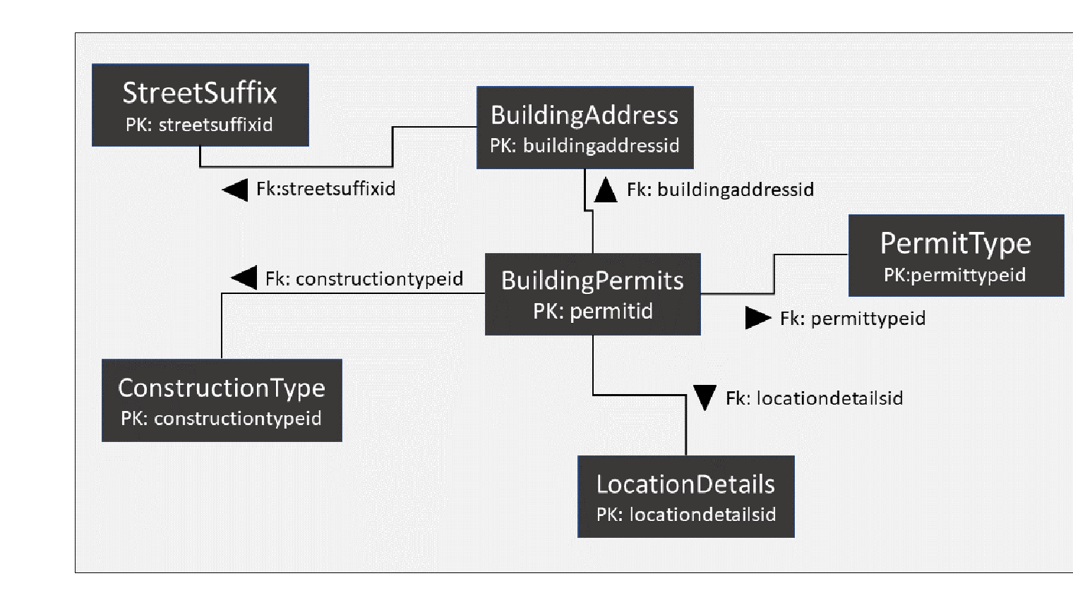

***Figure 1.0***

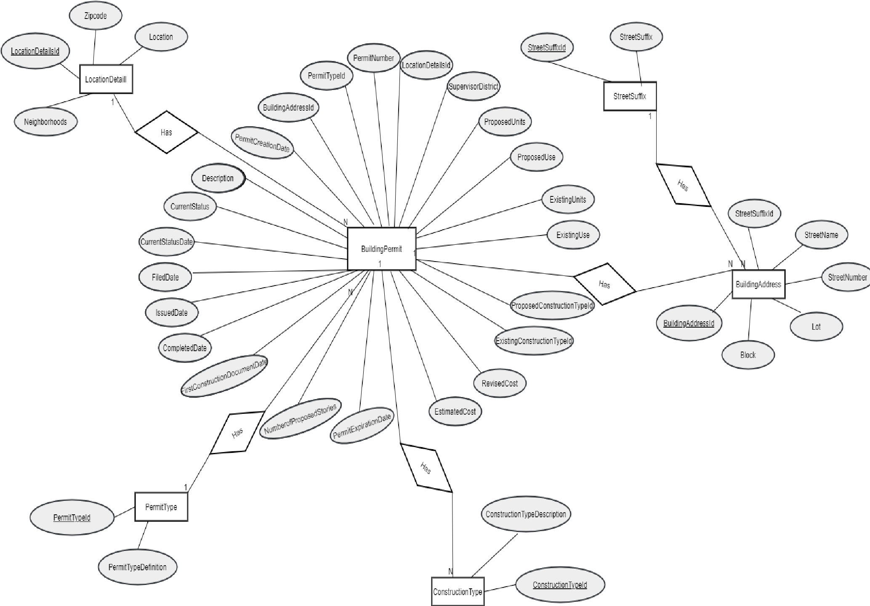

***Figure 1.1***

STEP 2 : SSAS Cube implementation

**Creating the SSAS project**

**1**.Firstly I opened the Visual Studio Data Tool in ‘Administrator ‘ mode

**2**.Then I created an **Analysis Service** project. I created a new project named “**BuildingPermits_SSAS**” as a project based on Analysis Services Multidimensional and Data Mining Project.

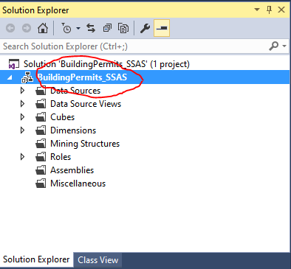

**3**.Then I Created a Data Source

* I right clicked on Data Sources in and selected New Data Source

**4**. After that I created a Data Source View

* I Right clicked on Data Source Views and select New Data Source View…and gave necessary details.
* In the **Select Tables and Views page**, first I clicked on ‘FactBuildingPermits (dbo)’and clicked **on >** button to move it to the Included objects window. Then I clicked on Add Related Tables button. Then I added all the tables to the Included objects window by clicking >> button. Then I Clicked Next.After that I Provided a data source view name; **‘DSV_Building Permits Data Warehouse’** and clicked Finish.

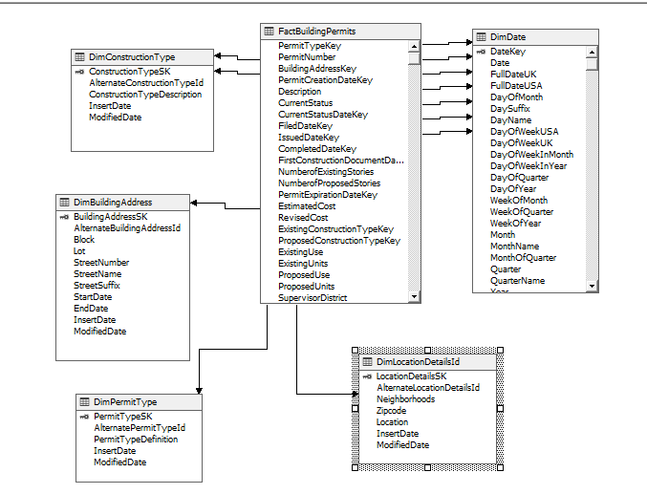

4.Then I created a Cube

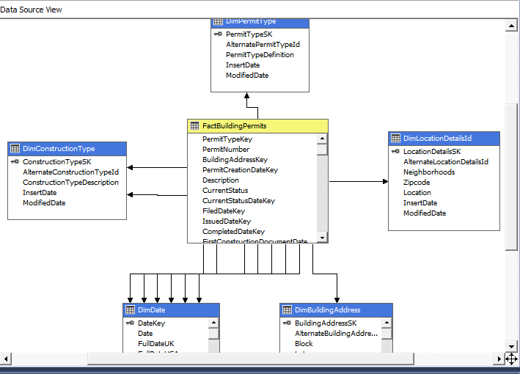

After, I added those data to SQL Management studio under Analysis.

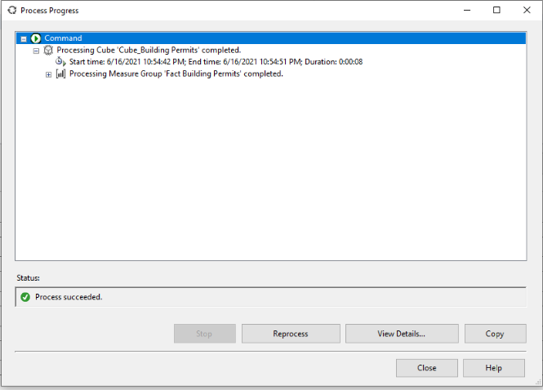

* Dimension Section

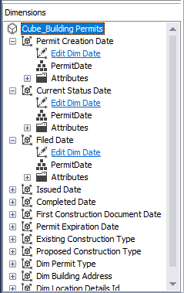

**5. After creating the cube I Deploied the Cube**

**I )** Right click on the project name, ‘**BuildingPermits_SSAS’** in solution explorer, and click on Deploy **.**

After thatI saw a pop-up window displaying the deployment completed successfully.

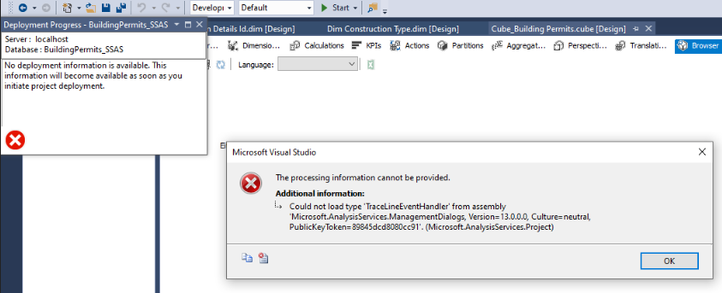

Before getting success I got this error .But I successfully solved that problem.

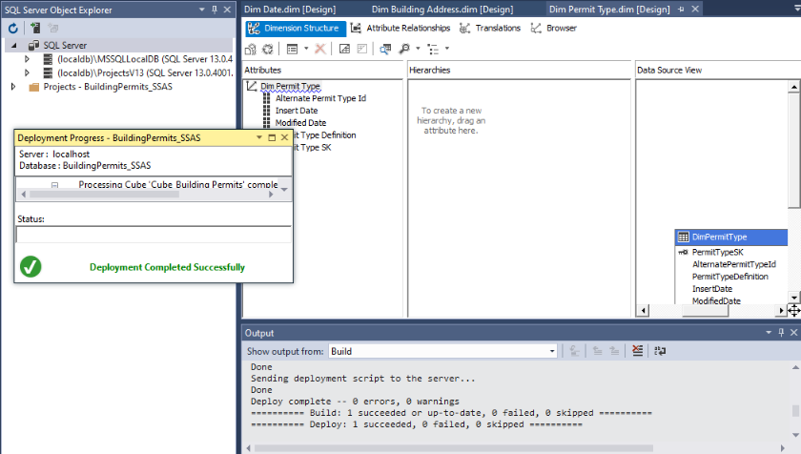

* Once successfully deployed, Browser tab under ‘**Cube_BuildingPermits**’ design window (‘**Cube_BuildingPermits.cube [Design]**’), will have the attributes of the model on the left hand side, where you can drag and drop the into the design area on the right hand side and dosome test analysis.

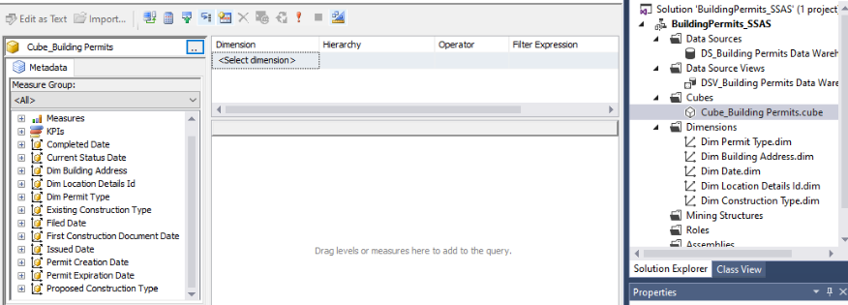

* To check the deployment in SSMS, I opened SQL Server Management Studio, then I clicked on Connect and select Analysis Services. I Provided credentials and logged in.

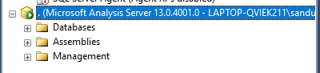

I expanded Databases, ‘**BuildingPermits_SSAS**’, and right click on ‘**Cube_BuildingPermits**’ and select Browse.

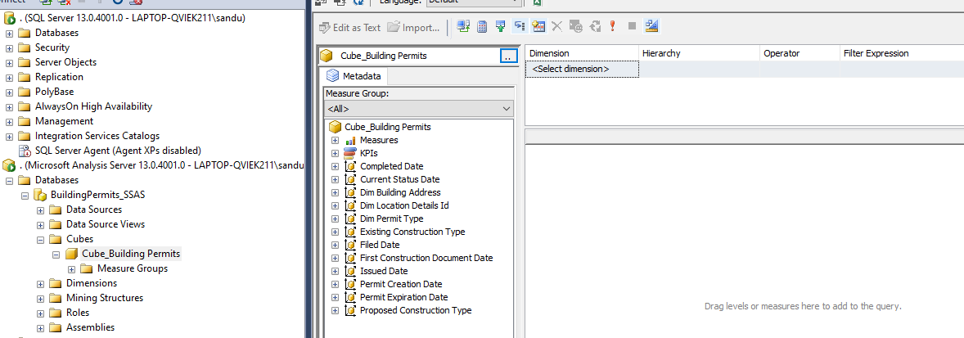

**6. After that I created a KPI**

I went back to Data Tools, located and went to KPIs tab in ‘**Cube_BuildingPermits**’ design window (‘**Cube_BuildingPermits**.**cube** [Design]’). In the KPIs tab, above KPI Organizer panel, located and clicked on New KPI button. I Named the KPI as ‘KPI Estimated Cost’, then selected ‘Fact Building permits’ as the Associated measure group and I gave the necessary details in the shown below.

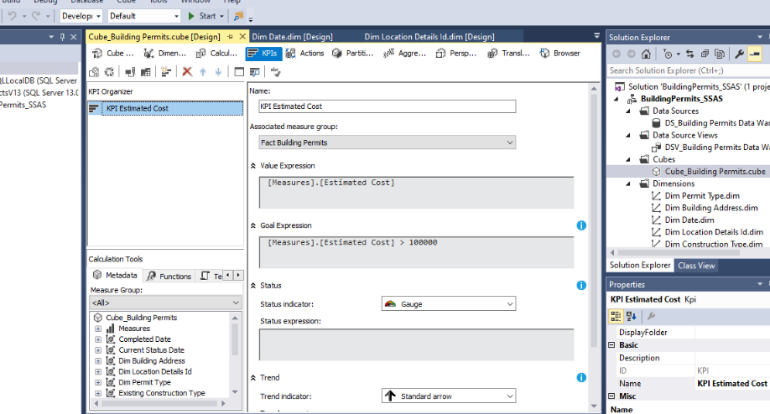

In order to update the cube, I right clicked on the cube name in the Solution Explorer; ‘**Cube_BuildingPermits**.**cube**’ and clicked Process.

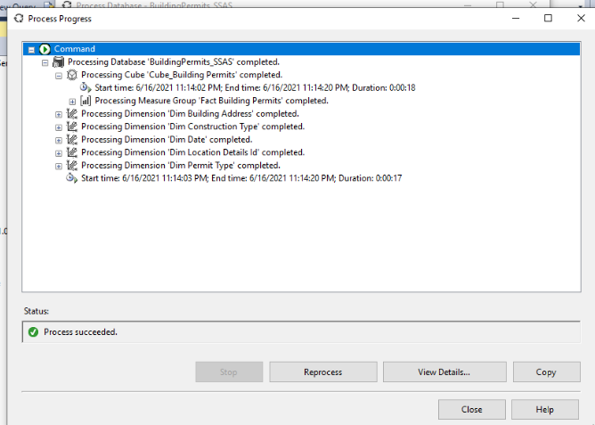

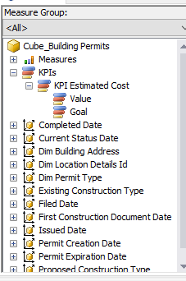

When I designing the cube ,I implemented a hierarchy for the date dimension

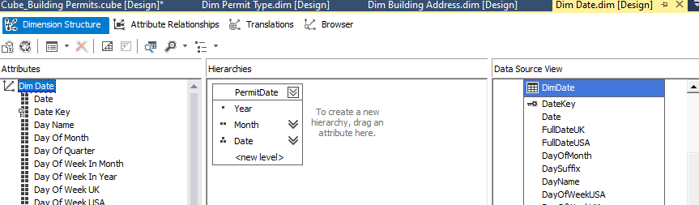

**STEP 3 : Demonstration of OLAP operations**

i) Connecting Excel to SSAS Cube using a MDX Query

* I Expanded the ‘**BuildingPermits_SSAS**’ project, and then Cubes Folder to locate the cube i created; ‘**Cube_BuildingPermits**’. Then Right clicked on the ‘**Cube_BuildingPermits**’ and selected Browse to open the Browser window. Then I Dragged and dropped necessary fields to create an analysis. In order to get the MDX query,I executed them and clicked design mode button.Then MDX query was be available.
* In order to use MDX queries, Excel must have an add-in called Power Pivot.So I enabled power pivot and went to new tab POWERPIVOT and clicked on Manage. A new Excel window opened and In the home tab of this new window, clicked on **Get External Data -> From Database-> From Analysis Service or Power Pivot**. In the Table Import Wizard window,I provided connection details to connect to SSAS Server and provided the database name (‘**BuildingPermits_SSAS**’), then tested the connection, and clicked **Next >** button. In the next window, I pasted the MDX query i copied, and clicked on Validate button to ensure there are no errors, and clicked Finish.

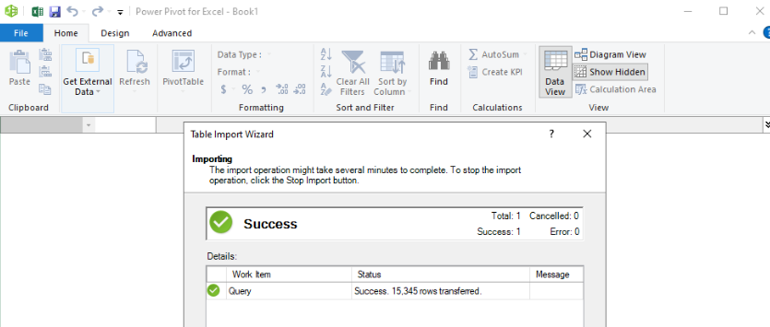

* Successfully imported dimension table and fact table data of the cube

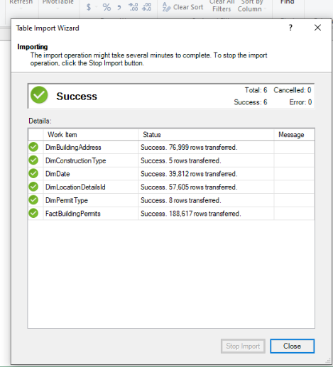

* Then I could see an excel sheet shown below

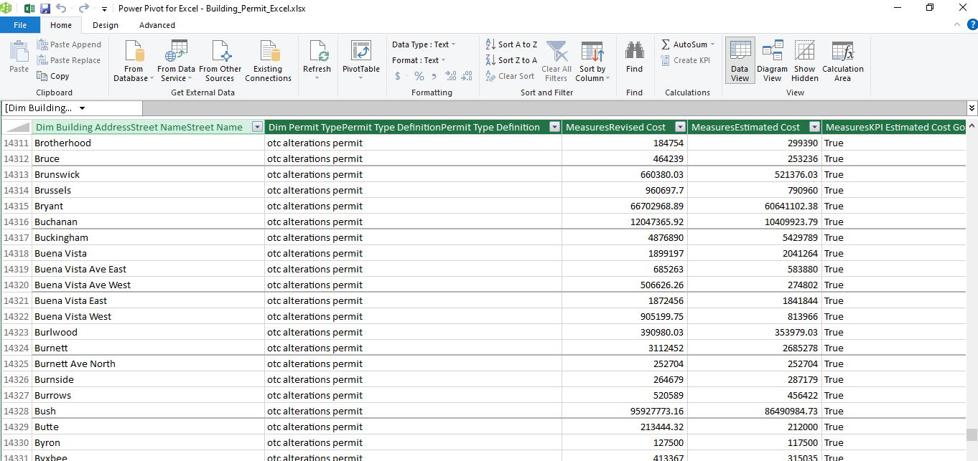

* After that I generated a Pivot Table area in POWERPIVOT tab in the original Excel workbook

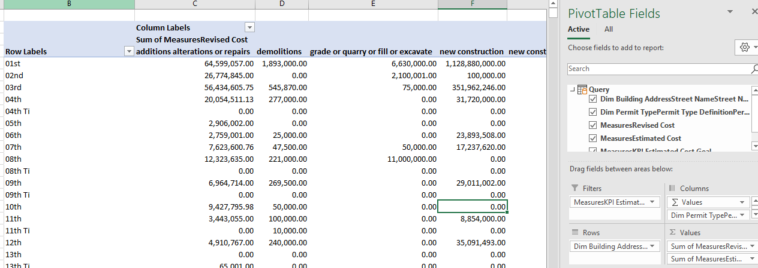

* By creating Power View dashboards, I demonstrated OLAP operations
* **DashBoard 1**

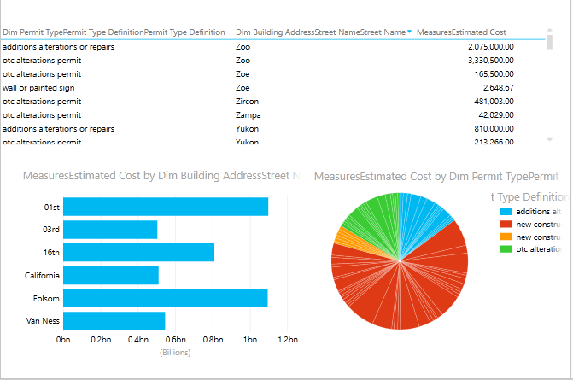

* **DashBoard 2**

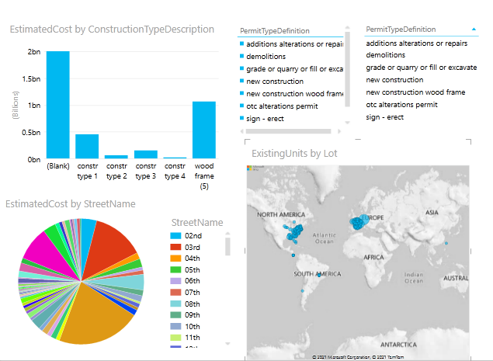

**STEP 4 : SSRS Reports**

**i)** Firstly I created a Data Source

Firstly I Opened Report Builder tool. Then I Right clicked on the Data Sources and clicked Add Data Sources… to openup the Data Source Properties window. Then Provided a data source name; ‘**DataSourse_BuildingPermits_Data’**, and selected **Use a connection embedded in my report**. After that Selected **Microsoft SQL Server** as the connection type. Clicked on the **Build…** button to create the connection. I created the connection to the ‘**BuildingPermits_Datawarehouse’**

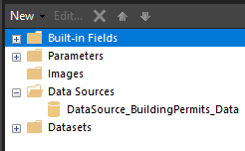

ii) Then I created a Dataset

I right clicked on the Datasets and clicked Add Dataset… to open up the Dataset Properties window.Then I gave the necessary details .

In the Query section, I designed a query shown below.

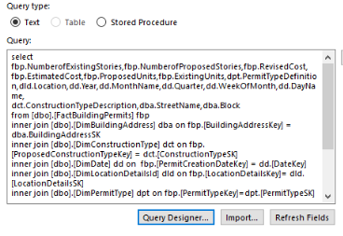

Then I created several datasets and parameters according to the generating reports. So I created several reports based on various data.

Report with a matrix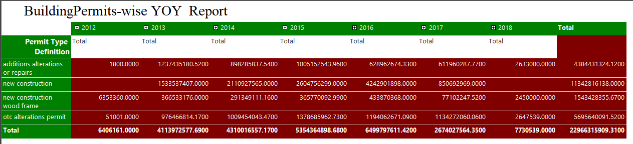

Matrix with one parameter

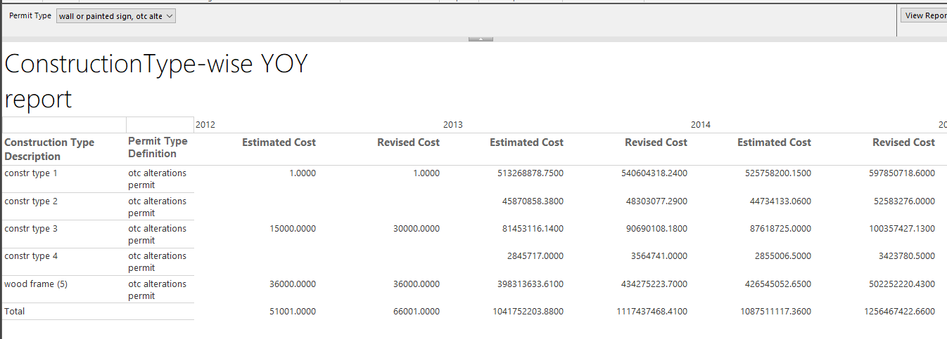

Matrix with two parameters

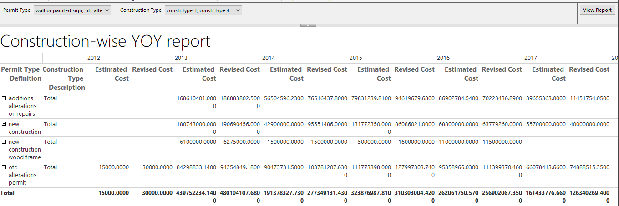

Drill Down Reports

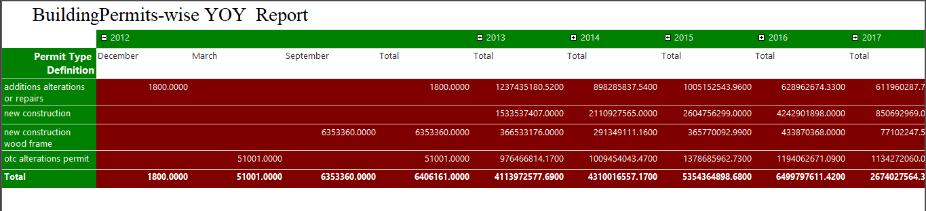

Drill through Reports

